1. List three real-life scenarios where a multimeter would be used to troubleshoot a computer or smartphone issue, and explain in one line how the multimeter helps in each case.
Ans :-
No. | Scenario | How the multimeter helps
1 | Computer power supply problem | Measures voltage to check whether the power supply is providing the correct output.
2 | Smartphone not charging | Checks the USB charging cable and charger voltage to identify a possible power problem.
3 | Laptop battery problem | Measures battery voltage to help identify a weak or faulty battery.
- Use a multimeter only if you know how to handle it safely. Do not open a power supply or probe a live circuit without proper training.

2. Watch a short YouTube video demo of a POST card in action (search for 'POST card motherboard test'), then write a brief summary (3-4 lines) describing what the POST card displays and what problem it helped identify in the video.<br><br><em><strong>Hint:</strong> Focus on the codes shown and how they relate to hardware issues.</em>
Ans :- A POST card is a diagnostic tool used to identify hardware problems when a computer starts. It displays error codes during the Power-On Self-Test (POST). These codes help technicians identify possible problems with the RAM, CPU, motherboard, or graphics card. In the demonstration, the displayed code helps narrow down which hardware component may be causing the startup failure.

3. Download and install any free software diagnostic tool (such as HWMonitor, Speccy, or CrystalDiskInfo), run it on your laptop or desktop, and take a screenshot of the main dashboard showing system health details.<br><br><em><strong>Constraint:</strong> Blur or crop out any personal
information before submitting.</em>
Ans :-
Steps:
- Open the official website: CPUID HWMonitor.
- Download and install HWMonitor.
- Open the software on your laptop or desktop.
- Check the system health details, such as CPU temperature, voltage, fan speed, and battery information (if supported).
- Take a screenshot of the main dashboard.
- Blur or crop out any personal information before submitting the screenshot.
- HWMonitor helps monitor computer hardware conditions and identify problems such as high CPU temperature.
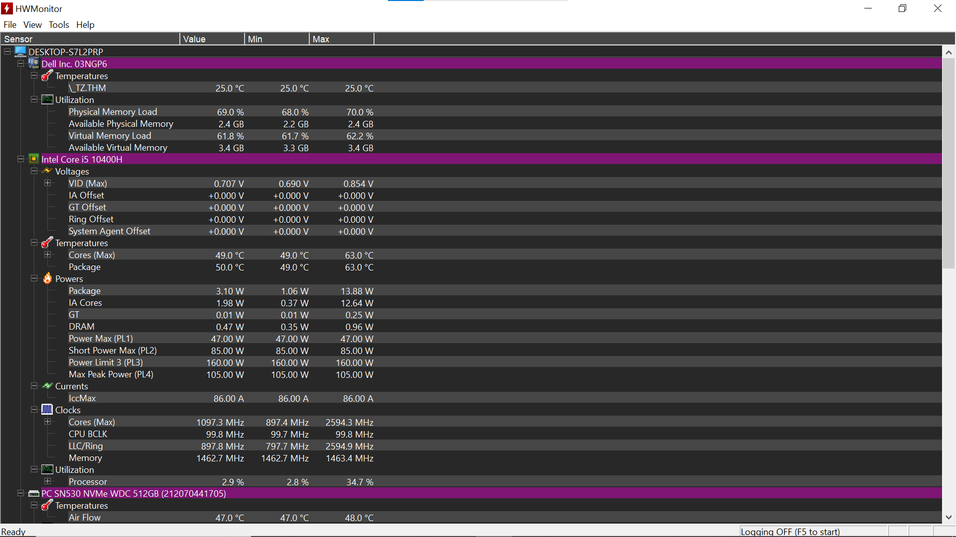

4. Compare the use of a multimeter, POST card, and software diagnostics by creating a table with three columns (Tool, What it checks, Example Problem Detected) and fill in at least one example for each tool.
Ans :-
Tool | What it checks | Example Problem Detected
Multimeter | Voltage, current, and electrical continuity | Faulty power supply or incorrect voltage
POST Card | Error codes during computer startup (POST) | RAM or motherboard startup failure
Software Diagnostics | CPU temperature, storage health, and system performance | Overheating CPU or failing hard drive

